**LAPORAN TUGAS**

**PEMROGRAMAN WEB**

**PEKAN 4 : PHP – PENGENALAN DASAR**



**DISUSUN OLEH:**

|  |  |
| --- | --- |
| **NIM** | **L200220277** |
| **NAMA** | **MHD. FARHAN LUBIS** |
| **KELAS** | **D** |

**PROGRAM STUDI INFORMATIKA**

**FAKULTAS KOMUNIKASI DAN INFORMATIKA**

**UNIVERSITAS MUHAMMADIYAH SURAKARTA**

**2023**

# **DAFTAR ISI**

**DAFTAR ISI** 2

**1)** **PHP implementasi fungsi built-in date (date.php)** 3

**a)** **Kode** 3

**b)** **Hasil** 4

**2)** **PHP implementasi fungsi built-in string (string.php)** 4

**a)** **Kode** 4

**b)** **Hasil** 6

**3)** **PHP implementasi fungsi built-in date (date.php)** 6

**a)** **Kode** 6

**b)** **Hasil** 8

**4)** **PHP implementasi fungsi built-in date (date.php)** 8

**a)** **Kode** 8

**b)** **Hasil** 10

# **PHP implementasi fungsi built-in date (date.php)**

## **Kode**

|  |
| --- |
| <!DOCTYPE html> <html lang="en"> <head>  <meta charset="UTF-8">  <meta name="viewport" content="width=device-width, initial-scale=1.0">  <title>Ramadan Date</title>  <link rel="stylesheet" href="css/style.css"> </head> <body>  <div class="container">  <h2>Ramadan Date</h2>  <p>Implementasi beberapa fungsi built-in PHP terkait tanggal dan waktu untuk studi kasus tentang Ramadan.</p>   <div class="info">  <?php  *// Mendapatkan tanggal hari ini*  $today_date = date('Y-m-d');  echo "Today's Date: $today_date <br>";   *// Membuat waktu untuk pukul 00:00:00 pada tanggal 1 Ramadan 2024*  $ramadan_start = mktime(00, 00, 0, 3, 11, 2024);  echo "Ramadan starts at: " . date('Y-m-d H:i:s', $ramadan_start) . "<br>";   *// Mendapatkan waktu saat ini*  $current_time = time();  echo "Current Time: " . date('Y-m-d H:i:s', $current_time) . "<br>";   *// Mengonversi string waktu ke timestamp dengan*  $iftar_time = strtotime('tomorrow 17:48:00');  echo "Iftar Time Tomorrow: " . date('Y-m-d H:i:s', $iftar_time) . "<br>";  ?>  </div> </div>  </body> </html> |

## **Hasil**

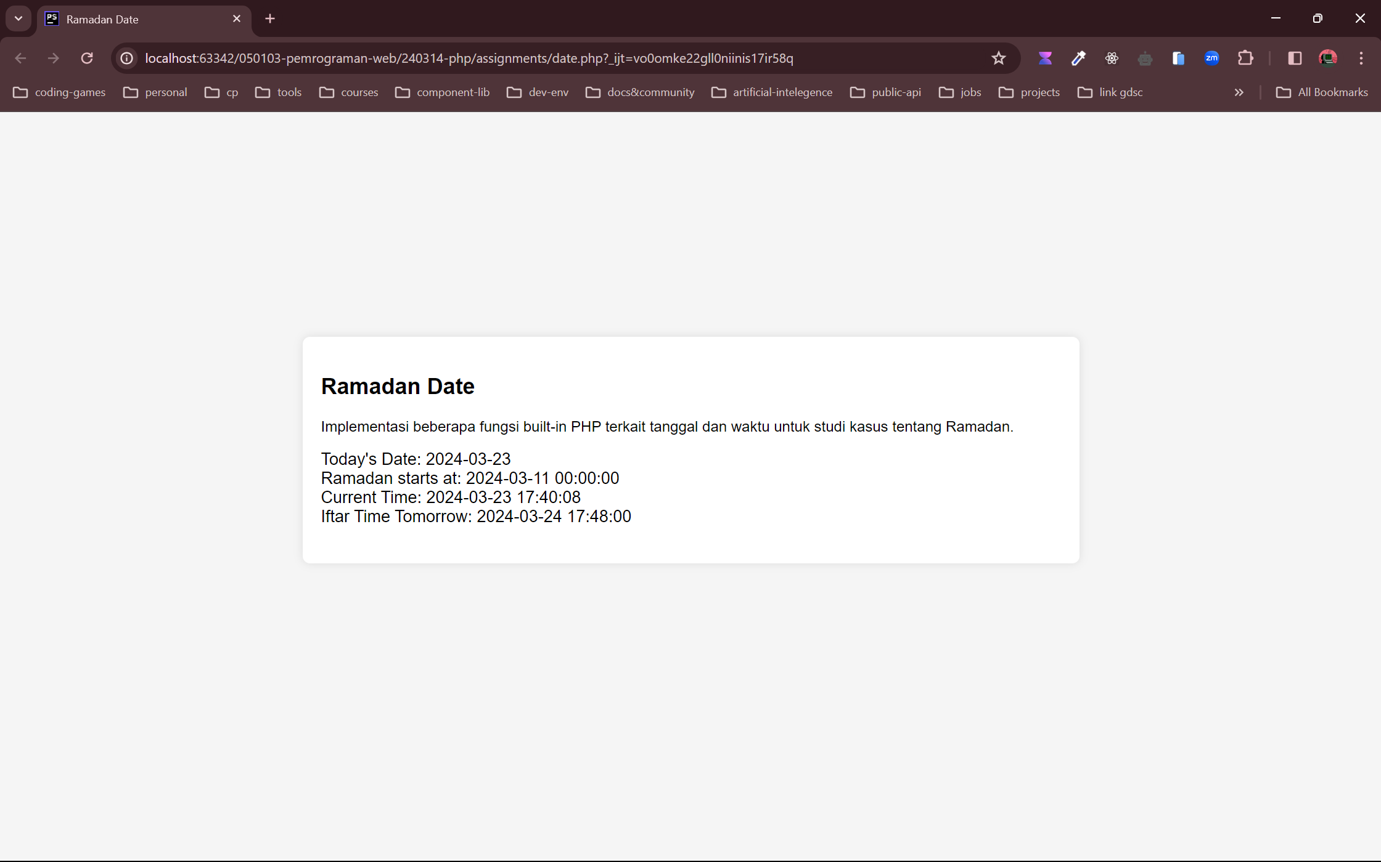

# **PHP implementasi fungsi built-in string (string.php)**

## **Kode**

|  |
| --- |
| <!DOCTYPE html> <html lang="en"> <head>  <meta charset="UTF-8">  <meta name="viewport" content="width=device-width, initial-scale=1.0">  <title>Ramadan String</title>  <link rel="stylesheet" href="css/style.css"> </head> <body>  <div class="container">  <h2>Ramadan String</h2>  <p>Implementasi beberapa fungsi built-in PHP terkait manipulasi string untuk studi kasus tetang Ramadan.</p>   <div class="info">  <?php  *// Mengambil panjang dari string*  $message = "Marhaban ya Ramadan!";  echo "Length of the string \"$message\": " . strlen($message) . "<br>";   *// Membandingkan dua string*  $ramadan = "Ramadan";  $eid = "Eid";  $comparison = strcmp($ramadan, $eid);  if ($comparison == 0) {  echo "\"$ramadan\" is equal to \"$eid\"<br>";  } elseif ($comparison > 0) {  echo "\"$ramadan\" is greater than \"$eid\"<br>";  } else {  echo "\"$ramadan\" is less than \"$eid\"<br>";  }   *// Mencari kemunculan pertama dari sebuah string dalam string lain*  $email = "infotakjil@ramadan.com";  $domain = strstr($email, '@');  echo "Domain part of email \"$email\": $domain<br>";   *// Menggabungkan elemen-elemen array dengan sebuah string*  $takjils = array("Kolak", "Gorengan", "Es buah");  $takjils_implode = implode(", ", $takjils);  $takjils_join = join(", ", $takjils);  echo "Implode takjils: $takjils_implode<br>";  echo "Join takjils: $takjils_join<br>";   *// Membagi sebuah string menjadi array berdasarkan string pemisah*  $sentence = "Welcome to Ramadan Kareem";  $words = explode(" ", $sentence);  echo "Exploded words: " . implode(", ", $words) . "<br>";   *// Mengonversi karakter-karakter khusus ke bentuk entitas HTML*  $html_message = "<p>Ramadan Kareem</p>";  $encoded_message = htmlspecialchars($html_message);  echo "Encoded Message: $encoded_message<br>";  ?>  </div> </div>  </body> </html> |

## **Hasil**

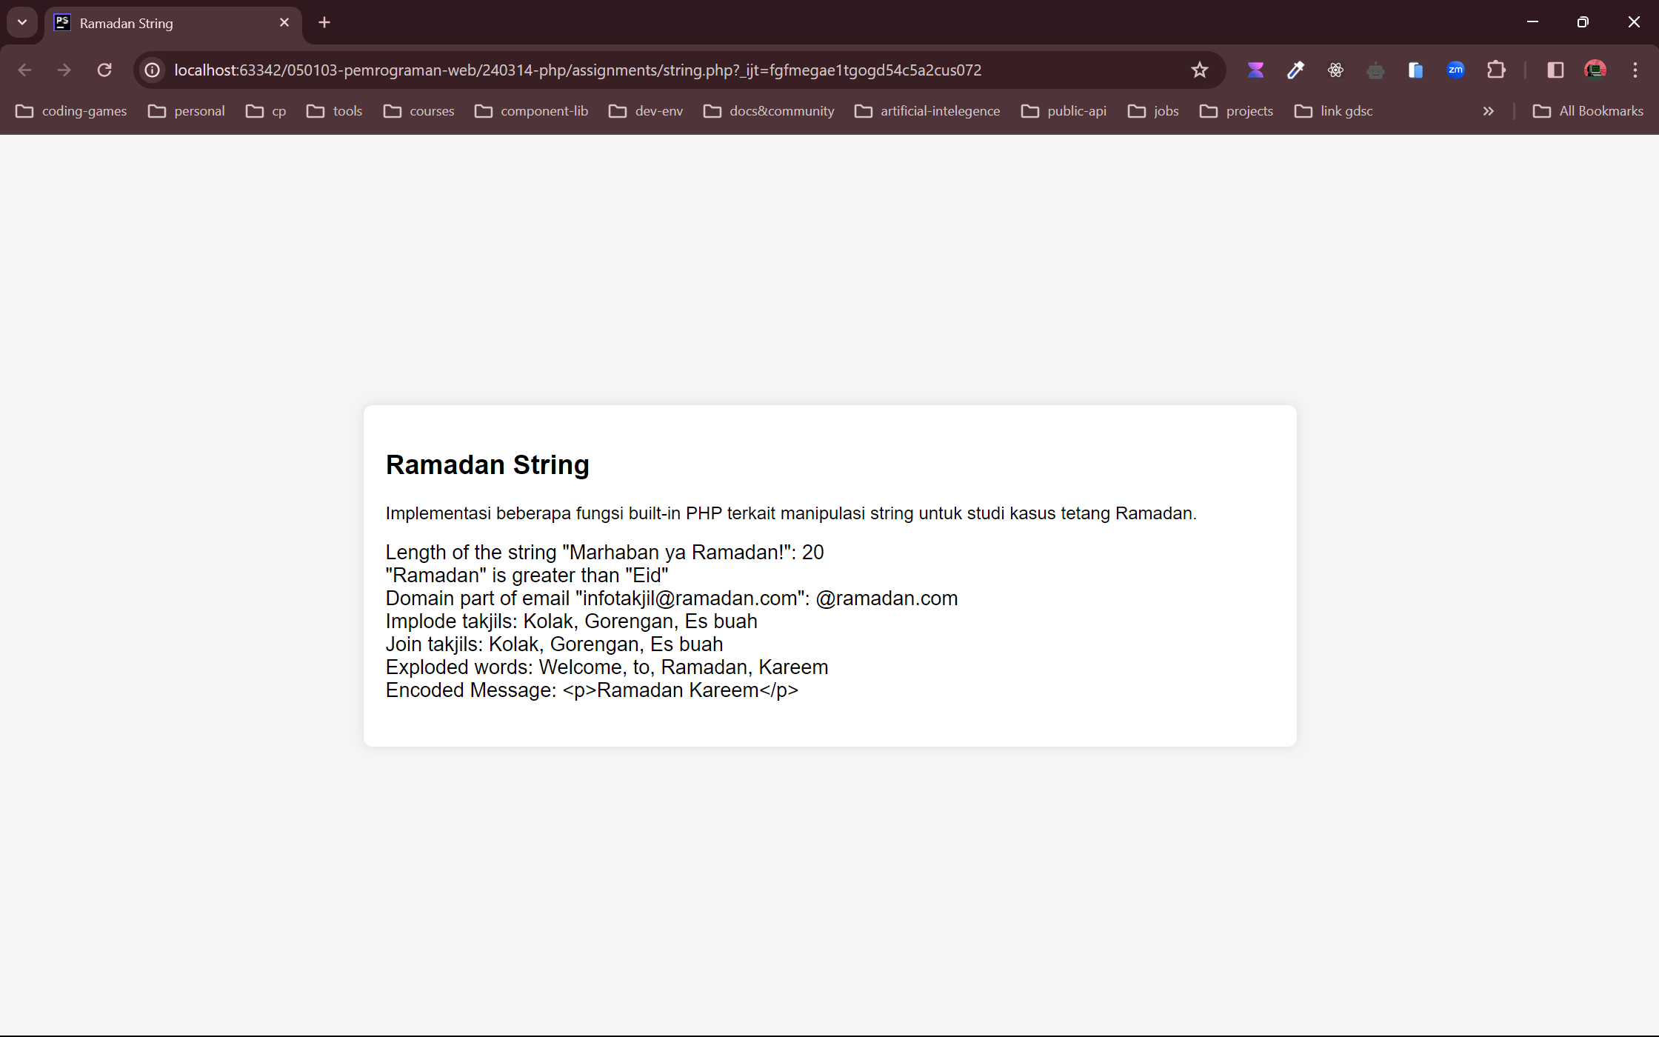

# **PHP implementasi fungsi built-in date (date.php)**

## **Kode**

|  |
| --- |
| <!DOCTYPE html> <html lang="en"> <head>  <meta charset="UTF-8">  <meta name="viewport" content="width=device-width, initial-scale=1.0">  <title>Math</title>  <link rel="stylesheet" href="css/style.css"> </head> <body>  <div class="container">  <h2>Ramadan Math</h2>  <p>Implementasi beberapa fungsi built-in PHP terkait matematika untuk studi kasus tentang Ramadan.</p>   <div class="info">  <?php  *# Mempangkat bilangan ke pangkat tertentu*  $base = 2;  $exponent = 3;  $result_pow = pow($base, $exponent);  echo "Result of $base raised to the power of $exponent: $result_pow<br>";   *// Menghitung logaritma dari bilangan*  $number = 10;  $number_log = log($number);  echo "logarithm of $number: $number_log<br>";   *// Mendapatkan nilai π (pi)*  $pi_value = pi();  echo "Value of pi: $pi_value<br>";   *// Menghasilkan bilangan bulat acak*  $random_number = rand(1, 100);  echo "Random number between 1 and 100: $random_number<br>";   *// Mencari nilai tertinggi dari beberapa nilai*  $numbers = [10, 20, 5, 30];  $max_number = max($numbers);  echo "Highest number in the array: $max_number<br>";   *// Mencari nilai terendah dari beberapa nilai*  $min_number = min($numbers);  echo "Lowest number in the array: $min_number<br>";   *// Pembulatan ke bawah dari bilangan pecahan*  $number_to_floor = 3.7;  $result_floor = floor($number_to_floor);  echo "Floor value of $number_to_floor: $result_floor<br>";   *// Pembulatan ke atas dari bilangan pecahan*  $number_to_ceil = 3.2;  $result_ceil = ceil($number_to_ceil);  echo "Ceiling value of $number_to_ceil: $result_ceil<br>";   *// Pembulatan dari bilangan pecahan*  $number_to_round = 3.5;  $result_round = round($number_to_round);  echo "Rounded value of $number_to_round: $result_round<br>";   *// Fungsi trigonometri (sinus, kosinus, tangen)*  $hilal_degrees = 45;  *// Mengubah derajat menjadi radian*  $hilal_radians = deg2rad($hilal_degrees);  $sin_value = sin($hilal_radians);  $cos_value = cos($hilal_radians);  $tan_value = tan($hilal_radians);  echo "Sine of $hilal_degrees degrees: $sin_value<br>";  echo "Cosine of $hilal_degrees degrees: $cos_value<br>";  echo "Tangent of $hilal_degrees degrees: $tan_value<br>";  ?>  </div>  </div>  </body> </html> |

## **Hasil**

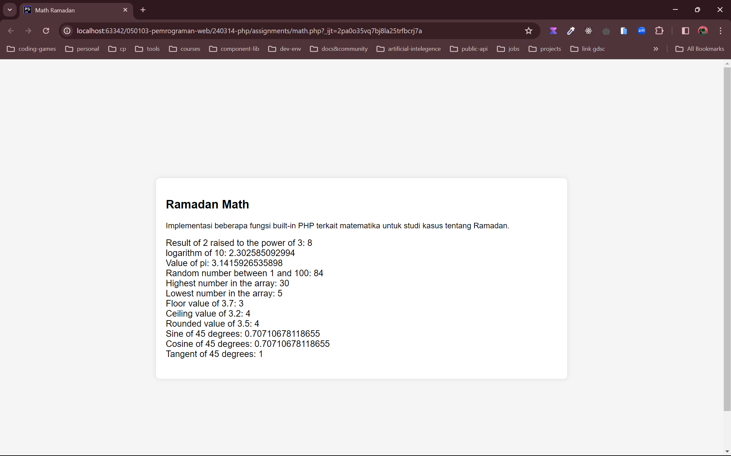

# **PHP implementasi fungsi built-in date (date.php)**

## **Kode**

|  |
| --- |
| <!DOCTYPE html> <html lang="en"> <head>  <meta charset="UTF-8">  <meta name="viewport" content="width=device-width, initial-scale=1.0">  <title>Ramadan Utility</title>  <link rel="stylesheet" href="css/style.css"> </head> <body>  <div class="container">  <h2>Ramadan Utility</h2>  <p>Implementasi beberapa fungsi built-in PHP terkait utilitas untuk studi kasus tentang Ramadan.</p>   <div class="info">  <?php  *// Menghitung jumlah elemen dalam array*  $takjils = ["kolak", "pisang ijo", "tahu goreng", "es buah", "es kuwut"];  $count = count($takjils);  echo "Number of elements in the array: $count<br>";   *// Memeriksa apakah sebuah variabel sudah diatur dan tidak null*  $iftar = 18;  $fasting = null;  $message = "Its time to iftar!";  echo "Is iftar set and not null? " . (isset($iftar) ? "Yes" : "No") . "<br>";  echo "Is fasting set and not null? " . (isset($fasting) ? "Yes" : "No") . "<br>";  echo "Is message set and not null? " . (isset($message) ? "Yes" : "No") . "<br>";   *// Memeriksa apakah sebuah variabel kosong*  $activity = '';  $takjil = 0;  $friend = [];  $money = null;  $pray = True;  echo "Is activity empty? " . (empty($activity) ? "Yes" : "No") . "<br>";  echo "Is takjil empty? " . (empty($takjil) ? "Yes" : "No") . "<br>";  echo "Is friend empty? " . (empty($friend) ? "Yes" : "No") . "<br>";  echo "Is money empty? " . (empty($money) ? "Yes" : "No") . "<br>";  echo "Is pray empty? " . (empty($pray) ? "Yes" : "No") . "<br>";  ?>  </div>  </div> </body> </html> |

## **Hasil**

